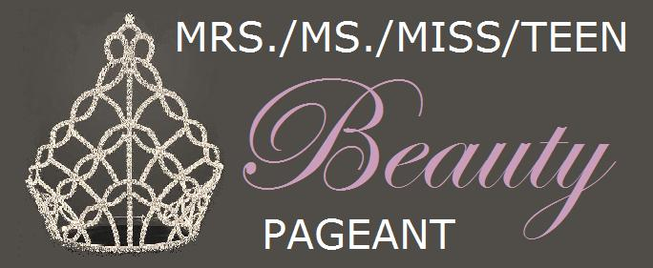

Personal Information:

Full Name:
Address 1:
Address 2:
City:
State:
Zip:
Phone:
E-mail:

Title Requirements:
If you do not win the national title, you will represent your city and state name. Though it may already be reported, above, in your mailing address, we ask you to please restate the city and state you live in for clarity purposes.

What City do you live in?

What State do you live in?

Platform Competition:
Please write a brief one paragraph essay about what your main goal in life is; why it is and how you plan to achieve it.

Interview Competition:

- List three words that describe your personality; and explain why they do?

- What do you do in your spare time and why?

- Do you have any hobbies, talents, or skills? Explain why you do them and how you achieved them.

- Have you received or won any awards, titles, or honors?

- Why did you enter the Mrs./Ms./Miss/Teen Beauty Pageant and what will you do with your title?

Note: Thank you for your entry! Please e-mail this resume to (glitter_customer_service@yahoo.com). Please include your Head-Shot Photo for the Photogenic Competition. Attach the photo as a BMP, JPEG, or PNG file. Your photo should have good resolution and clarity.

